DEVOPS DOCUMENT 6

(Git commands)

Clone:

git clone is a Git command line utility which is used to target an existing repository and create a clone, or copy of the target repository. In this page we'll discuss extended configuration options and common use cases of git clone

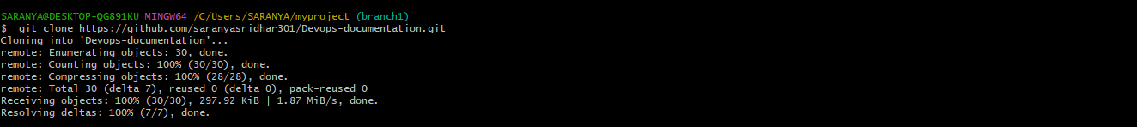

Push:

The git push command is used to upload local repository content to a remote repository. Pushing is how you transfer commits from your local repository to a remote repo. It's the counterpart to git fetch , but whereas fetching imports commits to local branches, pushing exports commits to remote branches.

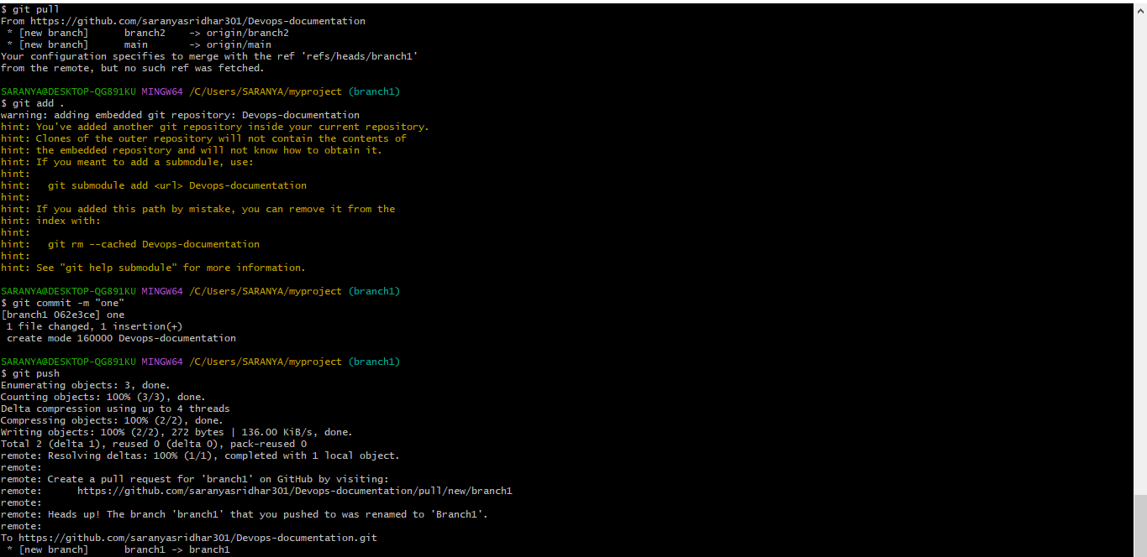

Merge:

Merging is Git's way of putting a forked history back together again. The git merge command lets you take the independent lines of development created by git branch and integrate them into a single branch. Note that all of the commands presented below merge into the current branch.

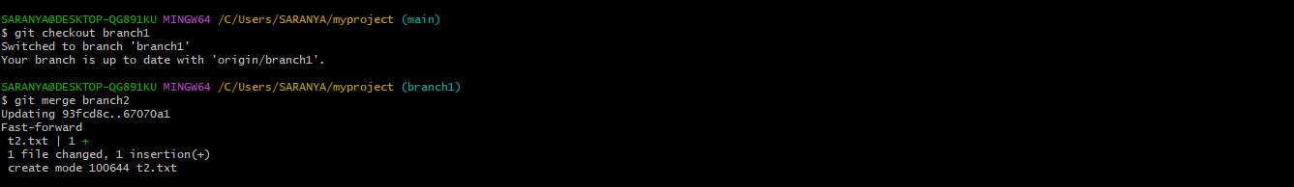

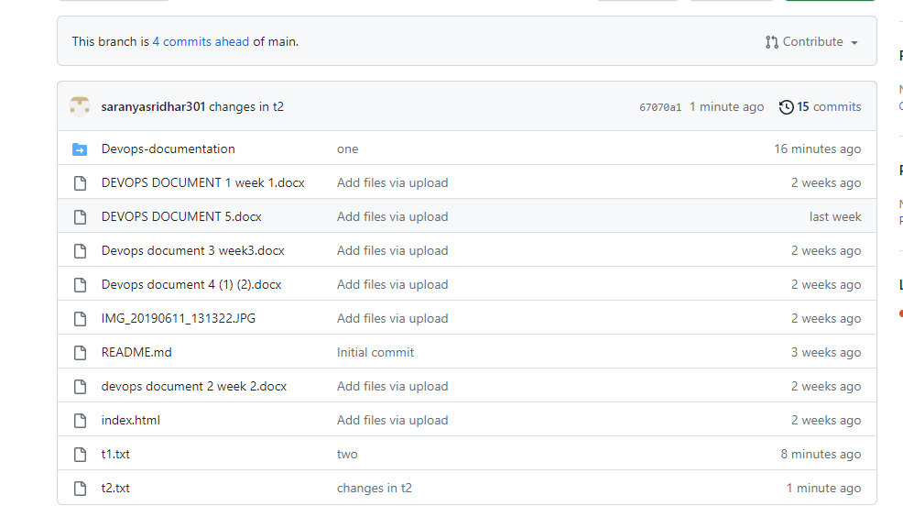

Revert:

The git revert command is a forward-moving undo operation that offers a safe method of undoing changes. Instead of deleting or orphaning commits in the commit history, a revert will create a new commit that inverses the changes specified. Git revert is a safer alternative to git reset in regards to losing work

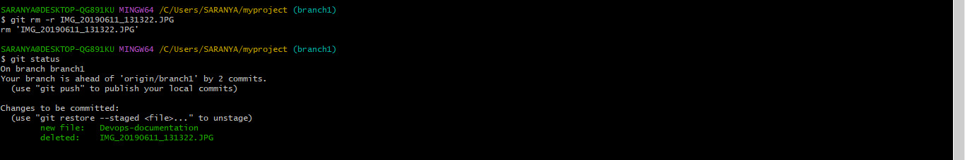

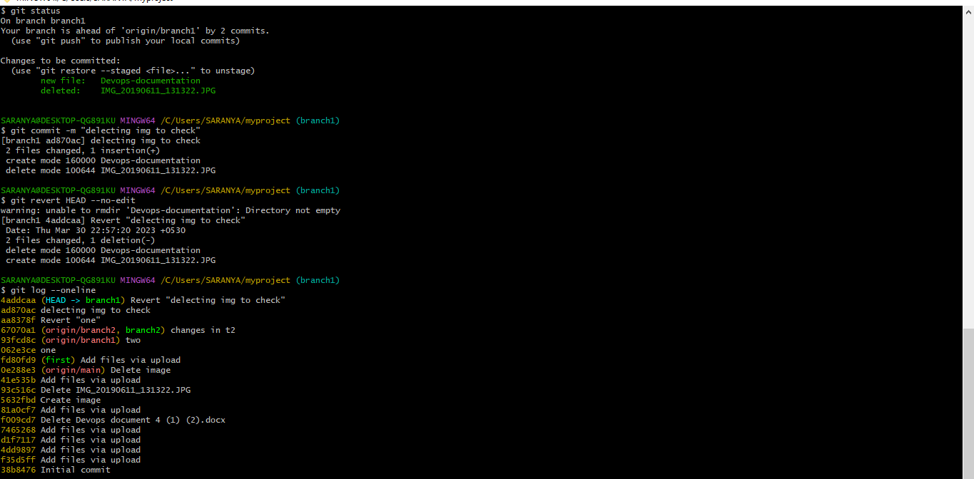

Reset:

reset is the command we use when we want to move the repository back to a previous commit, discarding any changes made after that commit.

